~ŽABLJAK~

Our whole country is bursting with history and amazing legends about the establishment of those. Montenegro is the mother to towns full of tradition and heritage. I chose Žabljak because even though many overlook it, taking into consideration only the nature that’s making it beautiful. But never the less, Žabljak is an important piece in the the history of Montenegro.
Žabljak is located in the centre of Durmitor with the population of just under 4,000. Not is it only the highest situated town in Montenegro, with an altitude 1,456 meters, but it is the highest situated town on the Balkans.
Although being perceived as an unapproachable teritory, the history remembers many tribes who have tried to settle down. The first settlements were by Illyrians, or to be more percise by their tribe Autariati. Unfortunately for them, in th e IV century B.C they have been suppressed by Celts and were forced to leave the teritory. Then again a change happened and this teritory was recaptured by Roman citizens until the VII century. In the VII century it was inhabited by Slav tribes.
From 1482 to 1857 the attacks of the Turkish towards this teritory were rough, the people from Žabljak resisted.
The first Slav name of this teritory was not Žabljak, but Varezina voda (Vareza’s Water) beacuse of the strong source of drinking water that was one of the main reasons this teriotry was inhabitated in the first place. After that the name that was given to the same tritory was Hanovi, originally ’’Anovi’’ because it was a resting place for the trade caravans. Finally the name that we use today, ŽABLJAK was settled in 1870. On this very day, when the town was reneamed for the last time, the construction works of a church, school and captain’s home began all at the same time. It was a turning point for the development of Žabljak, that unfortunately the wars destroyed. The only remaining is the church of Sv.Preobraženja (Holy Transfiguration) that was built in 1862. as a reminder of the Montenegrin victory against the Ottomans.
Undoubtedly other significant parts of the heritage of Žabljak are Greece cemeteries, Medieval fortification of Pirlitor, Dobrilovina Monastery and Tepca village.
When it comes to the Greece cemeteries it is a legend that says ’’ Once upon a time, Greeks inhabited this region. Somewhere in May, the snow fell, and they dented the plowshare into the surface and abandoned this area. They left behind the cemeteries, and this area gained the name The Greek cemetery at Mount Durmitor’’. The citizens of Žabljak left the tombs untouched out of respect. They are under the protection of UNESCO.

Pirlitor was a medieval fortress built on the periphery of the Tara river canyon. Sadly only a small part stayed till today. But it a piece worth visiting because it is the remaining wall of the fortress’s highest point giving a breathtaking overlook. Surrounding Pirlitor is an urban legend, probably the most famous one from the teritory of Žabljak. The legend is about Duke Momčilo who lost his life due to his wife’s treason. Although Momčilo had a horse with wings, called Jabučilo, a sword with eyes, and apparently was invinsible, he was defeated by his enemy, the greedy king Vukašin who fell in love with Momčilo’s wife, Vidosava. Vidosava returned the feelings and burned the wings of Jabučilo, the horse, so Duke Momčilo was unable to defeat Vukašin. Duke Momčilo died. As a result of sorrow because his owner died, Jabučilo, the horse, threw himself in the Black lake. There are rumors that even today in some occasionts you are able to hear the cry of Jabučilo.
In the Dobrilovina Monastery you can see wall paintings that are partly preserved. Besides that the special attraction are the preserved plastic ornaments, lozenges and rosettes.
Last but not least important, the Tepca village, known to be the first and only village that existed in this area in the XV century.
Before the World War II, Žabljak was a small town with a rising impact on the tourism field, attracting tourist from many places, but especially from Italy. The future for Žabljak seemed bright at that moment, but was crashed shorty after when the World War II happened. Žabljak was completely burned down. No foundations left. But with the strong will of the citizens it came to it’s feet. Žabljak rebuilt itself. Standing high and proud today as the main centre of Monenegro’s tourism. The capital of tourism as we like to say.
Attraction that bring us many tourist to Žabljak are skiing, rafting, mountaineering, hiking as well as mountain biking. Žabljak is the perfect palce for an adventurous spirit that will welcome you with heartfelt people and traditional cousine that includes domestic alcohol drinks as rakija, and specialties as kačamak and tučanik.
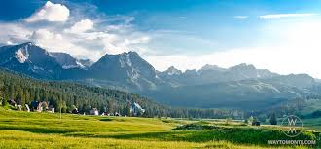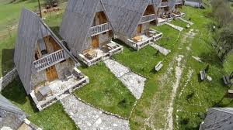
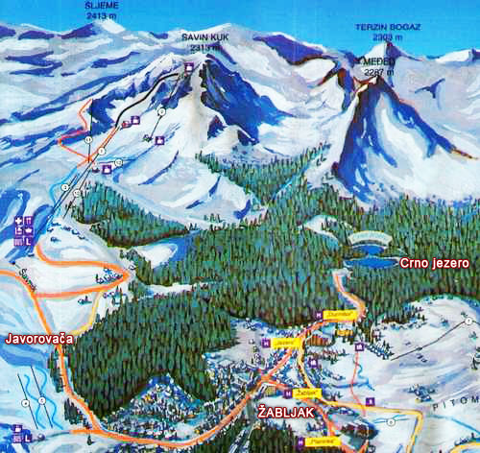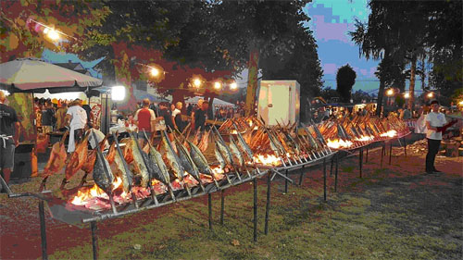
MILANA GARDAŠEVIĆ
NIKOLA ŠOROVIĆ
IX-2

