ST. TRYPHON`S DAY
Montenegro has some really great celebrations, but this one is very special for me. It`s St. Tryphun`s Day in Kotor, February 3rd, the day of the patron saint of Kotor and Kotor’s Diocese, whose cult has been present in this area for 1,210 years!
St. Tryphon was born in Campsada (Asia Minor) in the then Roman province of Apamea, in the Christian family. The respect of this saint began after the martyrdom death in Nice, where he was tried before the prefect of all Asia Minor of Aquileia (during the reign of the Roman emperor Decius). The body of St. Tryphon after his death was transferred to Campsada, from there to Constantinople and from Constantinople to Kotor.
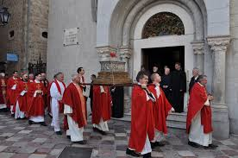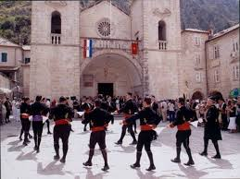St. Tryphon festivities start in Kotor on 27th January with “Lode” – lauding the glory of St. Tryphon, the patron saint of Kotor and Kotor Diocese, read by “young admiral” of Kotor Navy. On that day, in 1192, accompanied by the sound of St. Tryphon dance, the white flag with the image of the Saint was lifted on the mast of the cathedral for the first time. The celebration begins on 2nd February with a Holy mass in Kotor cathedral and the blessing of the Saint, followed by the solemn transfer of the relics and incensing of the holy relics (the relics will be incensed by six Orthodox and six Catholics). On Saint Tryphon Day, 3rd February, there are holy masses in the cathedral, On Sunday, 4th February, the program will begin in front of the main town gate, by welcoming of the Bokelian Navy and the brass band from Tivat, and it will continue on the square in front of the cathedral, where the Navy will perform its traditional dance. After that, there will be the procession along the streets and squares of the town carrying the relics of Saint Tryphon. The end of the festivities will be marked by lowering of the flag from the cathedral mast on 11th February.

