USEFUL VOCABULARY
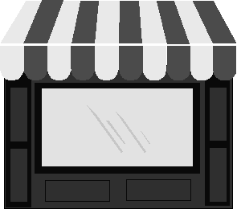
Shop(s) | Customer(s) | Cashier(s)
 | 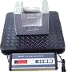 | 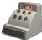
Wallet(s) (m)  Purse(s) (f) | Scales | Till(s)
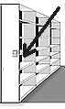 | 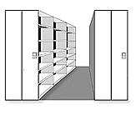
Shelf | Shelves | Barcode(s)
 | 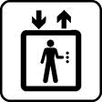
Trolley(s) | Lift(s) | Bag(s)
 | 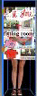
Basket(s) | Changing Room(s) | Escalator(s)
 | Ways to pay
 | 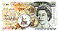 | 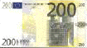
Cheque(s) | Cash | Note(s)
Coin(s) | Credit card(s)  Debit card(s)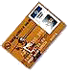

Where to buy what
 | Chemist's
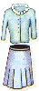 | Ladies Clothing Shop or Boutique
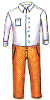 | Mens Clothing Shop or Tailor's
 | Shoe Shop or Cobbler's
 | Jeweller's
 | Electrical Store
 | Toy Shop or Toy Store
 | Record Shop
 | Book Shop
 | Newsagent's
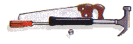 | Ironmonger's
 | Optician's
 | Department Store Supermarket
 | Butcher's
 | Fishmonger's
 | Greengrocer's
 | Baker's
 | Grocer's
 | Florist's
 | Post Office

Useful Shopping Phrases
Finding a Shop | Opening Hours
QUESTIONS  - Can you recommend a good toy/clothes shop?  - Is there a chemists/supermarket in the area?  - Where can I get toothpaste/pet food?  - Where's the nearest shopping centre?  ANSWERS/COMMENTS  - There's a really good bookshop just around the corner.  - You can buy that here in the hotel.  - The best toy shop is in the shopping centre.  - The nearest one is a few miles away. | QUESTIONS  - What time do you open, please?  - What time do you close, please?  - What are your opening hours?  - Are you open all day?  - Are you open on Sundays?  ANSWERS/COMMENTS  - We're open 24/7. (24 hours a day / 7 days a week)  - We're closed at lunchtime, between 12 and 2pm.  - We're open from 9am till 6pm, Monday to Friday.
Shopping for Clothes | Paying
QUESTIONS  - Could you help me, please?  - Could you tell me where the ................ department is?  - Excuse me, I'm looking for a ......  - Is there somewhere I can try this on, please?  - Does it suit me?  - Do you have this in a (larger/smaller size) (different colour), please?  - Do you do alterations?  - Do you have a refund policy?  - Is this in the sale?  ANSWERS/COMMENTS  - It's too long / short.  - It's too tight / loose.  - The ladies / gents changing rooms are over there.  - You can bring it back and exchange it or get a refund within 2 weeks if you keep the receipt. | QUESTIONS  - Do you take credit cards?  - Do you give credit?  - Do you have a loyalty card?  - Does it have a warranty?  - Can I pay by cheque?  - Do you offer a cash discount?  - Could I have a VAT receipt, please?  - Could I leave my bags here and pick them up later?  ANSWERS/COMMENTS  - We take all the major credit cards.  - We only accept cheques with a cheque card.  - We are offering 6 months free credit with no deposit.  - Sorry, no.  - Yes, certainly.

