Teacher: Rajka Vuksanović
Fourth grade
Name:_____________ Mark:_____________

COMPLETE THE SENTENCES LIKE THE EXAMPLE
It is an ____ELEPHANT___.
It ___ CAN______ walk.
It____CAN_____ run.
It ___CAN'T___ climb trees.
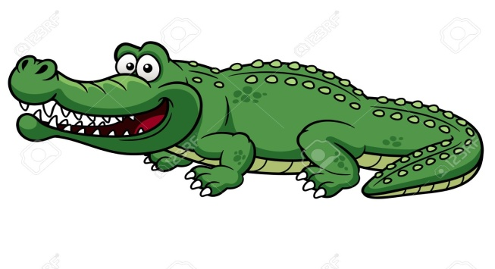
It is a _______________.
It ______________ swim.
It______________ fly.
It _____________ jump.
It is a _____________.
It _______________ fly.
It______________ walk.
It _____________ swim.
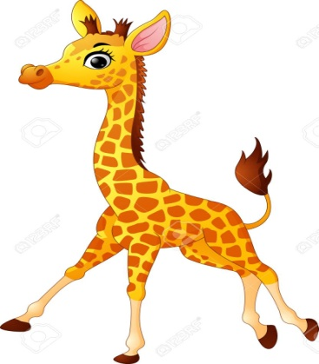

It is a ______________.
It _______________climb trees.
It _______________ run.
It _______________ fly.

A N I M A L S
COMPLETE THE BLANKS USING CAN OR CAN'T

1. Monkeys _______ drive but they _________ climb trees.
2. Cats ___________ sing a song but they __________ drink milk.
3. Kangaroos __________ dance but they _________ jump.
4. Horses _________ swim but they _________ run fast.
5. Dogs _________ eat a bone but they __________ speak.
6. A rabbit _________ play chess but it ________ eat carrots.
7. A fish ___________ swim but it __________ play the guitar.
8.Turtles ________ walk slowly but they ________ jump.
9. Lions ___________ read but they __________ roar.
10. Zebras _________ run so fast but they _________ play the piano.

ANSWER THE FOLLOWING QUESTIONS

1. Can cats swim?
____________________________.
2. Can dogs sleep?
_____________________________.
3. Can birds fly?
______________________________.
4. Can frogs sing?
______________________________.
5. Can elephants dance?
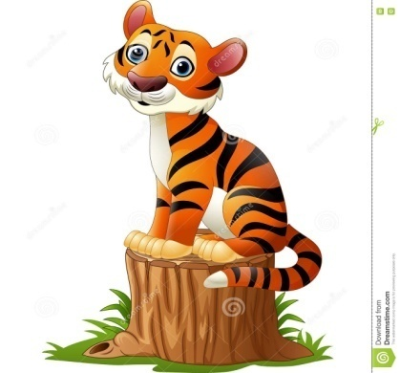
______________________________.
6. Can tigers sit?
______________________________.
7. Can crocodiles play the piano?
_______________________________.
8. Can mice eat cheese?
_______________________________.
9. Can turtles run fast?
_______________________________.
10. Can horses fly?
_______________________________.

